CSC170 Lab 11 HTML Forms

Due: Tuesday, October 31, 2017

For this lab, you will create a valid HTML form and insert it into your website. Use the comp provided (last page of this document) as a guide to create your own version of the form and follow the instructions below.

NOTE: Usually you make a copy of the last lab as a starting point for the current lab. This time you may choose whether you start with Lab 9 (PHP Includes), or if you don't want to deal with PHP Includes anymore you may revert to Lab 8 and make a copy of that instead.

# Part 1: Add a New Webpage to Your Website

* Make a copy of your Lab 8 or Lab 9 folder and name the new folder named **lab10**
* Open all the HTML files in your code editor and make the following changes to **all of them**:[1]
* Change the titles in the <title> tags to "Lab 10 - …"   
  e.g. <title>**Lab 10** - Shakespeare</title>
* Add a new menu item to the navigation on each page like this:   
  <li><a href="contact.html">Contact Us</a></li>
* Make a copy of any one of your HTML files; call the new file: **contact.html (or contact.php)**
* Edit the **contact.html** ( or .php) file
* *If you're using the non-PHP version of your website (from Lab 8) only…*In the NAV element, add the class, **class="is-current"** to the Contact Us anchor tag[2]
* In your **contact** file, remove the content *within* the ARTICLE element. (Leave the ARTICLE tag there.)
* In your **contact** file, remove the ASIDE element in its entirety.
* In your **contact** file, add the ID "contact" on the BODY tag like this:  
  <body **id="contact"**>
* In your **styles.css** file, target the ARTICLE on your contact webpage with a new style and tell it to span the CSS Grid, from lines 1 to 3, like this:  
  #contact article { grid-column: 1 / 3; }
* Within the ARTICLE, create a new H2 like this:[3]  
  <h2>**Contact Us**</h2>

# Part 2: Create the HTML Form

Refer to the comp at the end of this document as a guide, and then code the following form controls required for this assignment.

* Under the H2, create a <form> element. The <form> element must have two attributes:
  + A **method** that has a value of **"post"**
  + An **action** that has a value of **"#"**

## General Requirements

You must create a web form that uses the following elements:

* A set of **text input** fields (at least three) that use the attribute, type="**text**"   
  (or you can swap “text” for “email” or “url” or “tel” …whatever’s appropriate, so long as there’s at least three of them.)
* A set of **checkboxes**  
  At least three; they can be about whatever you want so long as they have something to do with your lab’s content.
* A set of **radio buttons**  
  At least three; they can be about whatever you want so long as they have something to do with your lab’s content.
* A **fieldset** and **legend** around your checkboxes and radio buttons.
* A **textarea** field
* A **submit** button with *custom words* on the button

Also, make sure you follow these requirements as you build your HTML form:

* Each form element that captures data (e.g. INPUT or TEXTAREA) you must include the following attributes in each:[4]
  + a **name** attribute
  + an **id** attribute

Remember: when writing values for **name=""** and **id=""** web developers typically use the same value, e.g. name="*email*" and id="*email*" …but *not* for radio buttons!  
  
For radio buttons, all the name="" attributes must be the same. But id="" attributes must be unique.

* As you create EACH form element that captures data (e.g. INPUT or TEXTAREA), you must create a label that uses the appropriate HTML element (**<label>**) and attribute (**for=""**) to associate it with the form element it's labeling.[5]

## The Checkbox and Radio Button Controls

* For each checkbox, include the attribute: **value=""** into which you can write some text that indicates what the checkbox represents
* For each radio button, include the attribute: **value=""** into which you can write some text that indicates what the radio button represents

## The Rest of the Form Controls

* Create a text area as shown in the comp to capture the user's comments.
* Create a submit button using the **value=""** attribute so it says something besides the default.

# Part 3: Style the Form

* In the HEAD of the contact.html file (or in your html-top.inc file) add a new LINK to another CSS file like this:  
  <link rel="stylesheet" href="css/form.css">
* In the **css** folder, create a new plain text file named **form.css**
* Next, you’re provided with some simple CSS for your **form.css** file that should work automatically to provide some basic styles to your HTML files.
* It is not required but you are encouraged to embellish the styles here – try your own variations to make it look nicer.

CSS you can ~~steal~~ use (with my permission):

**form {**

background-color: rgba(255,255,255,0.7);

padding: 30px;

width: 100%;

**}**

/* assuming you’re using H3s, you can do something like this...*/

**form h3 {**

margin-bottom: 0;

font-size: 16px;

**}**

/* To make the following style work, in your HTML you need to add class="fixed" to the <label> elements that label the type="text" elements...*/

**form label.fixed {**

display: inline-block;

width: 75px; /*...adjust as needed */

**}**

**form textarea {**

width: 100%;

height: 300px;

**}**

…but try to do better than this! Design the form so it works with your website's design.

# Comp

Use this as a guide for your Contact page. However, your styles should be appropriate for *your* website.

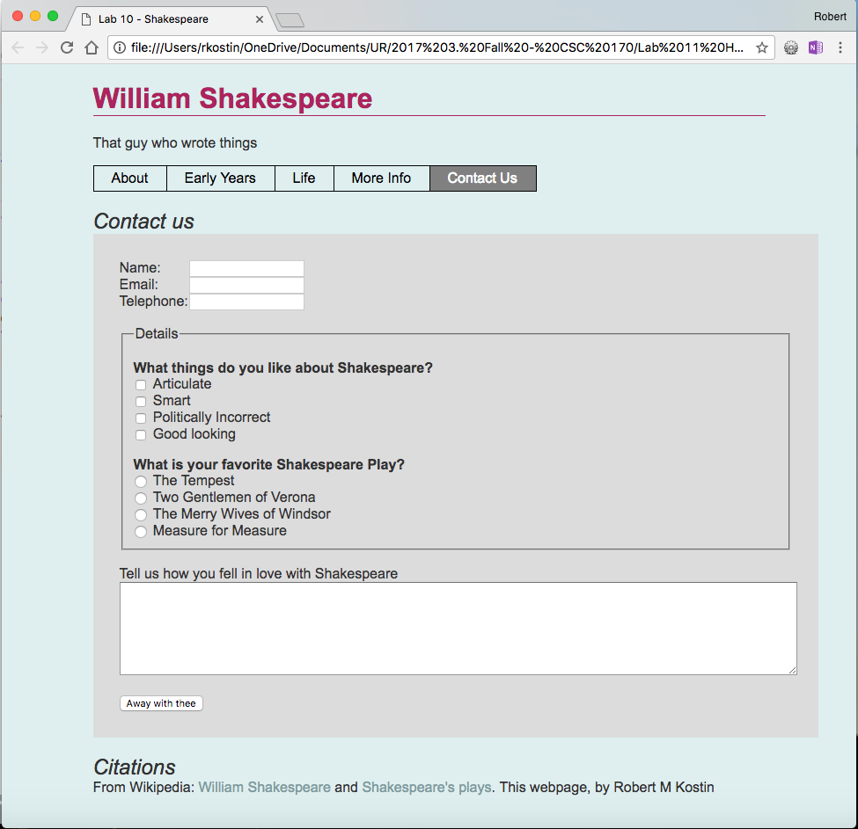

# Part 4: Upload and Report your Work

When you are done with your webpage, use an FTP tool to access your account on **urcsc170.org** and upload your files.

* In a web browser, go to this address to check your handiwork:   
  **www.urcsc170.org/*accountname*/lab10/contact.html** (where “*accountname*” is your account name)
* Remember: Use the W3C HTML validator (**validator.w3.org**) to check your work before you report it!
* In our Blackboard section, in Lab 10, post a link to your webpage to receive credit for this Lab.

1. Or if you're still using PHP includes (Lab 9), you simply have to update two **.inc** files
2. If you based this lab after Lab 9, then your "is current" menu highlighter will continue to be broken until we fix it later in the semester.
3. It doesn’t have to say, “Contact Us.” You can be creative here.
4. You do *not* have to use a **name=””** attribute nor an **id=””** attribute for the SUBMIT button.
5. In the example at the end of this document, the text, "What things do you like…" and "What is your favorite…" are *not* labels! They’re headings. (They’re H3s.)